Created by Dr. Zoltán Subecz. John von Neumann University, Kecskemét, GAMF Faculty of Engineering and Computer Science, Informatics Department
subecz.zoltan@nje.hu

InfinityFree – Free-Internet-Hosting-Provider
Google search:
Best free internet hosts PHP
https://www.websiteplanet.com/blog/best-free-php-hosting/
https://www.geeksforgeeks.org/best-free-web-hosting-services/
https://www.bitcatcha.com/web-hosting/php/free/
https://www.techradar.com/web-hosting/best-free-web-hosting

InfinityFree
https://www.infinityfree.com/

free, ad-free, 5GB Disc space, No Credit Card required

Tartalomjegyzék
1. Start 2
Registration 2
Create account 2
Choose a Domain Name 2
Your domain is ready! 3
Accounts menu / Select account 3
2. Using FTP (File Transfer Protocol) 3
Uploading files with FTP 4
With WinScp 4
With Total Commander 5
Upload test.txt file 6
INDEX.HTML OR INDEX.PHP FILES ARE REQUIRED!!! 6
3. Database usage 6
Database access - Start phpMyAdmin 7
4. Simple PHP exercise with Database 7

1. Start

Registration

https://dash.infinityfree.com/register

email: …..
password

Confirmation of registration with the received email.

Create account

https://dash.infinityfree.com/accounts


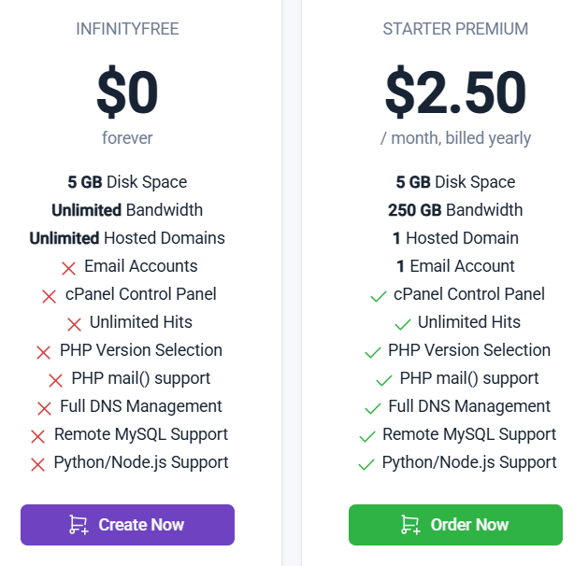

=> Create free account

Choose a Domain Name

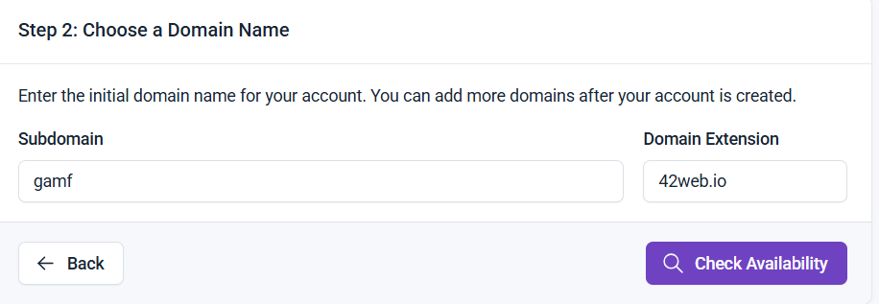

=> Check Availability



Your domain is ready!

http://gamf.42web.io/
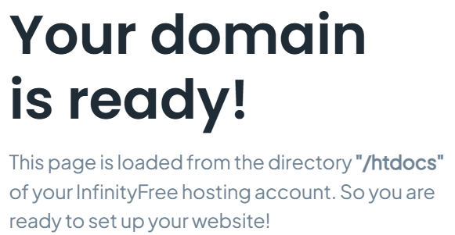

Accounts menu / Select account

Left side menu: 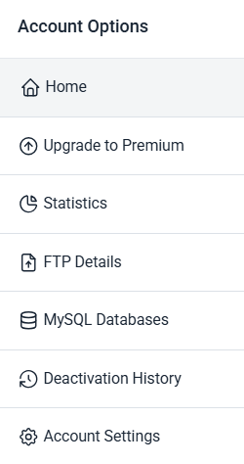
Top menu:

2. Using FTP (File Transfer Protocol)

Left side menu => FTP Details

You can read: Hostname, Username, Password,

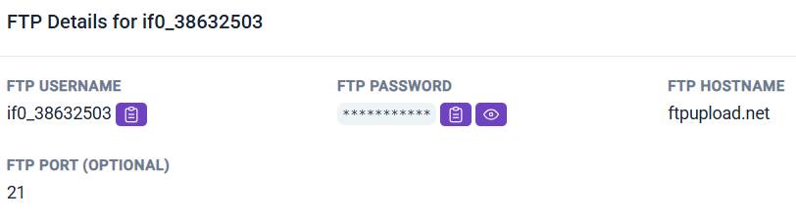

Set password:
Left menu => Account settings

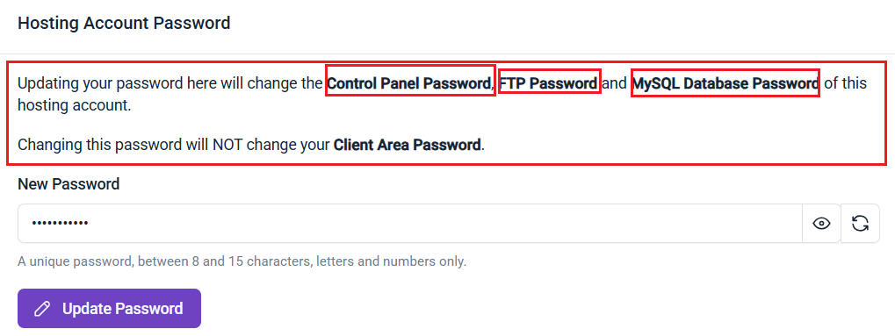

Uploading files with FTP

There are several free FTP clients. E.g., Total Commander client, FileZilla, …
With the data set on the storage.

With WinScp

https://winscp.net/eng/download.php
Download portable version:
https://winscp.net/download/WinSCP-5.11.1-Portable.zip

After unpacking and starting:
If SFTP doesn’t work, choose FTP:

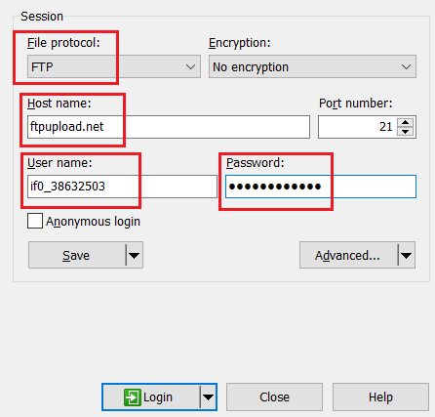

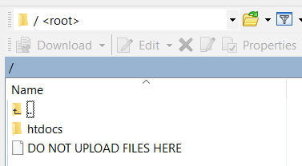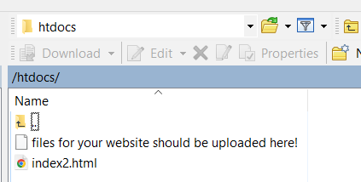
=> Go to htdocs folder

With Total Commander

One option: By clicking the URL button:

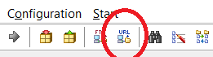

Or: Net menu / FTP new connection

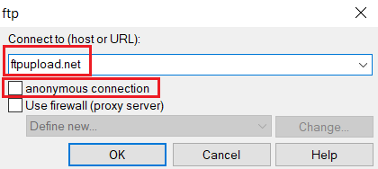

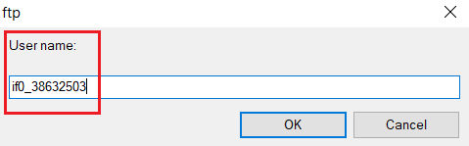

then enter the password

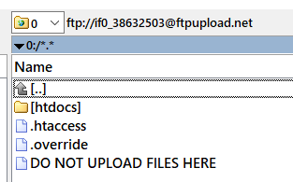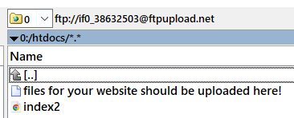

=> Go to htdocs folder

Upload test.txt file

Create only a simple text in the test.txt file: Hello
Copy the file to your htdocs folder:

http://gamf.42web.io/test.txt
=> Hello

INDEX.HTML OR INDEX.PHP FILES ARE REQUIRED!!!

otherwise you will get error messages!

Your website needs a file with the name index.php, index.html to work, located in the website's htdocs directory.

3. Database usage

Left menu => MySQL Databases

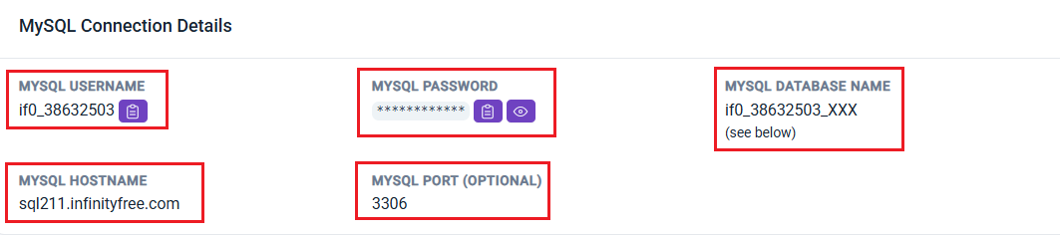

No databases found on this account:
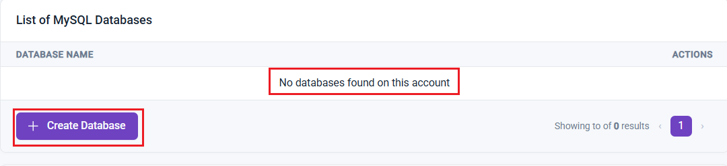

=> Create Database

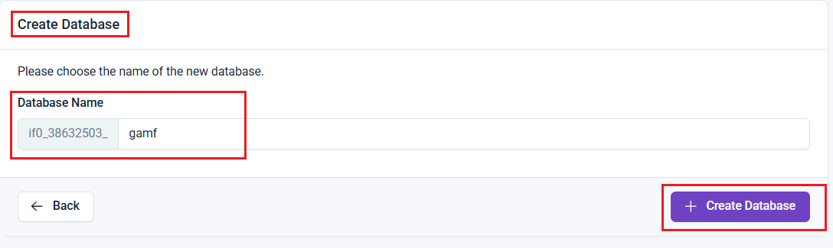

=> Create Database

Database access - Start phpMyAdmin

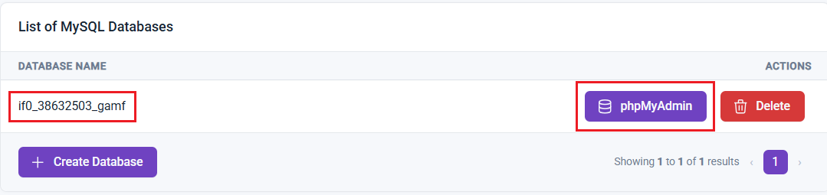

=> phpMyAdmin

You can manage databases here as well: Top menu => Control panel => MySQL databases

4. Simple PHP exercise with Database

Create the next table in the Database with phpMyAdmin:

CREATE TABLE users (
name varchar(45),
age int
);

INSERT INTO users (name,age) VALUES
('Name_1',25),
('Name_2',30),
('Name_3',40);

You have to set the red variables according to your settings:

testDB.php
<?php
try {
$pdo = new PDO('mysql:host=sql211.infinityfree.com;dbname=if0_38632503_gamf', 'if0_38632503','PASSWORD',array(PDO::ATTR_ERRMODE=>PDO::ERRMODE_EXCEPTION));
$statement = "Select name, age From users Where age<35";
$result = $pdo->query($statement);
foreach ($result as $row)
print $row['name'] . " " .$row['age'] . "<br>";
}
catch (PDOException $e) {
echo "Error: ".$e->getMessage();
}
?>

gamf.42web.io/testDB.php
Name_1 25
Name_2 30

